AC GUIDELINES FOR DEVELOPING AND REVIEWING AC POLICIES

In conjunction with the AC Policy Development and Review Policy, please follow the principles outlined below to ensure consistency across the online AC Policies and Procedures Manual (PPM) and comparability with the broader Higher Education sector. The new or revised policy will not be approved if the policy does not comply with the Policy Development and Review Policy or these guidelines. Where the proposed revision or new policy development does not comply with the guidelines below, the policy author may be asked to submit a justification.

Research
- The first step in developing or revising an AC policy is to conduct internal and external research of existing policy;
- AC prefers to revise current policies rather than create a new policy. Familiarise yourself with related AC policies to avoid unnecessary repetition and to ensure consistency within the existing AC PPM;
- Further information regarding conducting research is available in the procedures section of the Policy Development and Review Policy.

Policy Template
- Use the approved AC Policy Template as well as the New and Reviewed Policy Cover Sheet (Appendix II and III);
- Be sure to complete each section of the template, including benchmarking websites if relevant;
- Do not alter any of the fields or titles in the template.

Policy Title
- Policy titles should be short and generic;
- The title should be easily identifiable across Australian HE institutions;
- The type of document (e.g. ‘Policy’) is included at the end of the title. For example, ‘Risk Management Policy’, not ‘Policy for Risk Management’.

Policy Length
- An AC Policy should be succinct and generally not longer than four A4 pages;
- Do not copy and paste information from an external body (e.g. government legislation) – just include the link to that relevant information;
- Include additional important information in a separate handbook that can be more easily updated and modified – rather than in the official PPM e.g. AC Student Handbook.

Risk Assessment
- All policies should be submitted firstly to the policy owner or endorsement body for recommendation to the relevant approval body i.e. Academic Board or Executive Committee, as appropriate;
- It is the responsibility of the approval body to determine whether a policy should be deemed High Risk and referred to the AC Council for approval;
- If doubt exists as to the appropriate risk rating for a policy, the approval body will refer the change to the AC Council.

Appropriate Language
- Write the policy in plain English, be clear and concise, and avoid complex language and long paragraphs;
- Use present tense and third person;
- Select the words carefully; use words that are clear about what is mandatory (e.g. must, will) and what is discretionary (e.g. may, should);
- Use positive, inclusive and neutral language (e.g. they, their, chair);
- Please consult the Editorial Requirements section of these guidelines to ensure you use the correct formatting;
- Avoid using a specific label, such as the name of a software product. Generic terms require less maintenance;
- Use commonly understood language rather than jargon, which requires specialist knowledge.

Use of Acronyms
- Always write the full name or term in the first instance, with the acronym in brackets. Then use the acronym throughout the rest of the policy;
- The first instance of AC should be presented as, “Alphacrucis College (AC)”, and then always subsequently referred to as “AC” or “the College”.

Use of Tables/Images/Graphics
- Any images or graphics included in policy must be inserted as a picture only; i.e. jpeg, png, bmp (‘SmartArt’ will not display on the AC website);
- Minimise the use of tables, where possible. Instead, use subheadings and bullet points.

Elements of the Policy and Procedure Template
Organisational Groups and Policy Categories
- There are three organisational groups of AC policies:
  - Academic;
  - Governance; and
  - Management.
- AC Policies are categorised according to the department for which they are to be implemented. For example, the Academic Administration category houses all policies that are endorsed by the Academic Administration Committee and implemented by the Chair of Academic Administration Committee;
- If doubt exists, the endorsement body will refer this to relevant approval body for confirmation.

Purpose Statement
- The purpose statement should be between 1 – 3 sentences (maximum);
- Do not include the history as to how the policy was developed, regulatory motives, or any procedural steps.

Scope
- The Scope of the policy should be short and broad e.g. “all students and staff”;
- Do not name specific personnel.

Policy Statement
- The policy statement should seek to answer the following questions:
  - What are the major conditions or restrictions of the policy?
  - What is expected of the stakeholders?
  - Are there exclusions or exceptional circumstances?
- The policy statement should not include background details on the policy nor should it contain procedural steps.

Responsibility for Implementation
- The responsibility for implementation should usually be a specific position e.g. Director of Research;
- For further details, consult the College’s Organisational Structure, Delegations Policy and Governance Framework Policy;
- Do not name specific staff members.

Related Legislation
- Limit the inclusion of related legislation to that which is absolutely necessary as a legal requirement;
- Include the name of the document and link to the government website homepage, to avoid broken hyperlinks overtime;
- This list will be published below the policy statement;
- Do not duplicate the content of the legislation/regulations/government policy.

Related Policies
- Only include AC policies;
- This will be published in the Fact Box at the top of the policy webpage;
- You should not provide a summary or duplicate the content of the related policy;
- Do not include a hyperlink to the related policy. This will be handled by the administrator when publishing the policy on the AC Website.

Use of Supplementary Material
- AC policy and procedural statements should be generic;
- Where possible, create supplementary handbooks, manuals, guidelines or external forms to reduce the word count of the policy and make changes easier.

Defined Terms
- A limited list of defined terms may be incorporated at the beginning of the policy statement if necessary.

Procedure Statement
- Most policies should include a section on procedures relating to the policy;
- Include brief statements about the process or steps to be followed to implement the policy;
- The procedure statement should seek to answer the following questions:
  - How will the major conditions or restrictions of the policy be addressed?
  - How will the exclusions or exceptional circumstances of the policy be addressed?
- The procedural statement should not include background details on the policy;
- Procedures should be clear and succinct, usually in chronological order of the required procedure;
- Procedures should not be aspirational but should list what processes should be undertaken;
- Clearly identify which position, department or body is involved in each step of the procedure.

Editorial Requirements
- Headings are capital and bold, not underlined, unless in the case of multiple subheadings. Follow the format of previous policies for guidance. The Academic Board Terms of Reference Policy is a useful guide for the correct format of headings and subheadings;
- Do not use numbers to separate headings or sub-headings, unless necessary;
- Bullet points are strictly ‘•’, unless numerals are more logical, in which case use ‘1.’ Any other bullet point, -e.g. ‘(a)’ or ‘i.’- is only used where you are using bullet points within bullet points etc.;
- There should be a semi-colon at the end of dot points and the final dot point has a full stop;
- Numbers are spelled out if lower than 10;
- There is only one space between full stop and new sentence;
- Always use British spelling (even if it comes to you with American spelling);
- Policies should be drafted in MS Word, using Calibri 11pt font, single spacing and 2.54cm margins.

Communication
The position noted on the policy as “Responsible for Implementation” is responsible for communicating the new (or revised) policy and relevant procedures to key stakeholders, including Higher Education Third Parties. Failure to communicate changes may result in delays in implementation and/or misunderstanding of the requirements.

APPENDIX I - Approval Procedures
The following procedures are outlined in the Policy Development and Review Policy and Curriculum and Assessment Quality Assurance System.

Minor editorial changes do not need endorsement or approval. Please contact the Quality Assurance Officer.

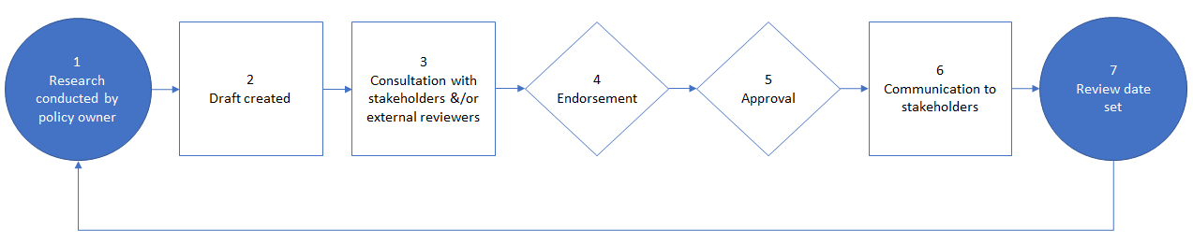
Procedure for Developing New Policy or Revising Existing Policy

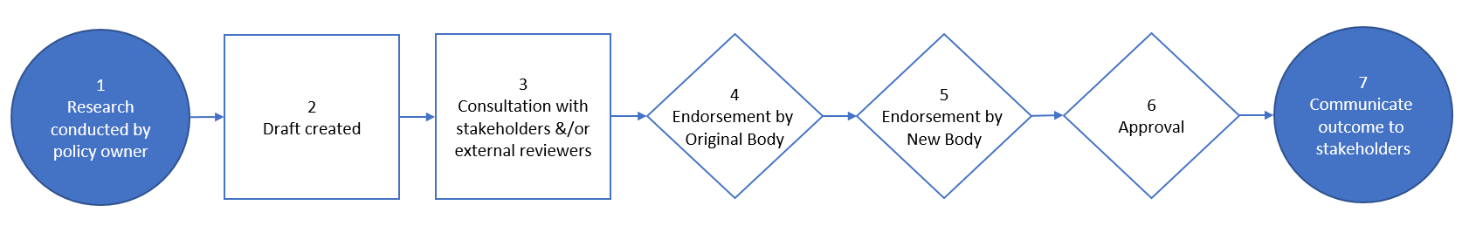
Procedure for Changing the Endorsement Body

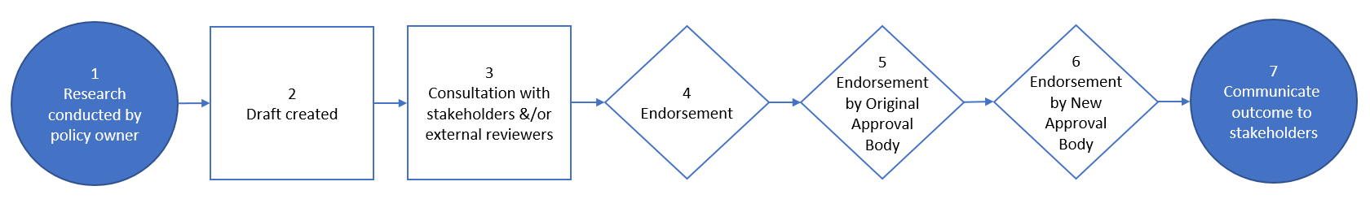
Procedure for Changing the Approval Body

APPENDIX II – Cover Sheet
The Cover Sheet below must be included at the beginning of any new or revised policy tabled for endorsement.

AC Policy Development or Review Report

Policy Name
Policy Owner
New or Revised Policy | New Revised
Risk Rating | Low Medium High (Based on Consequences and Likelihood)
Endorsement Body
Approval Body
Date Approved
People involved in Review

Please outline the key revisions made and reasons for these revisions. There is no need to itemise minor grammatical or terminology revisions.
Version of Policy | Revision Implemented | Reason for Revision
V.YYYY.MM.DD
V.YYYY.MM.DD
Add a new row for each version (change). Do not remove previous versions (changes).

Please list the external policies that this policy has been benchmarked against in the revision of this policy.
Institution | Web Link

APPENDIX III – Policy Template

[Policy Title]

Purpose

Scope

Policy
[HEADING ONE]
[Heading Two]
[Heading Three]

Responsible for Implementation

Related Legislation

Related Policies

Related Documents

Key stakeholders

Procedures

[Procedure Title]
[HEADING ONE]
[Heading Two]
Heading Three

https://www.uow.edu.au/about/policy/write/index.html
https://www.cu.edu/sites/default/files/APSwritingguide.pdf

